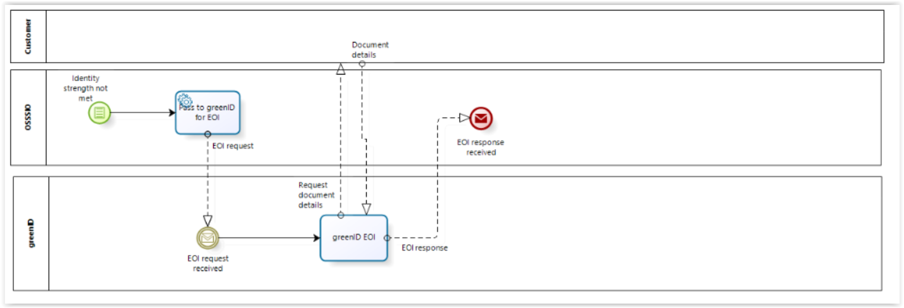

Diagram taken from Business Requirement Specification section 2.3

